**DAILY ONLINE ACTIVITIES SUMMARY**

|  |  |  |  |  |  |  |  |
| --- | --- | --- | --- | --- | --- | --- | --- |
| **Date:** | **18/05/2020** | | | | **Name:** | **Syed Rabeya Aamir** | |
| **Sem & Sec** | **8th B** | | | | **USN:** | **4AL16CS112** | |
| **Online Test Summary** | | | | | | | |
| **Subject** | | **SMS** | | | | | |
| **Max. Marks** | | **60** | | **Score** | | **56** | |
| **Certification Course Summary** | | | | | | | |
| **Course** | Introduction to Hadoop | | | | | | |
| **Certificate Provider** | | | **Great learning** | **Duration** | | | **30 mins** |
| **Coding Challenges** | | | | | | | |
| **Problem Statement:1) finding frequency of each character in a string and to print even and odd for series. 2) java program** | | | | | | | |
| **Status: COMPLETED** | | | | | | | |
| **Uploaded the report in Github** | | | | **YES** | | | |
| **If yes Repository name** | | | | **rabeya** | | | |
| **Uploaded the report in slack** | | | | **YES** | | | |

**Online Test Details**:

Test on module 3 (Random number generation)

Snapshot of test

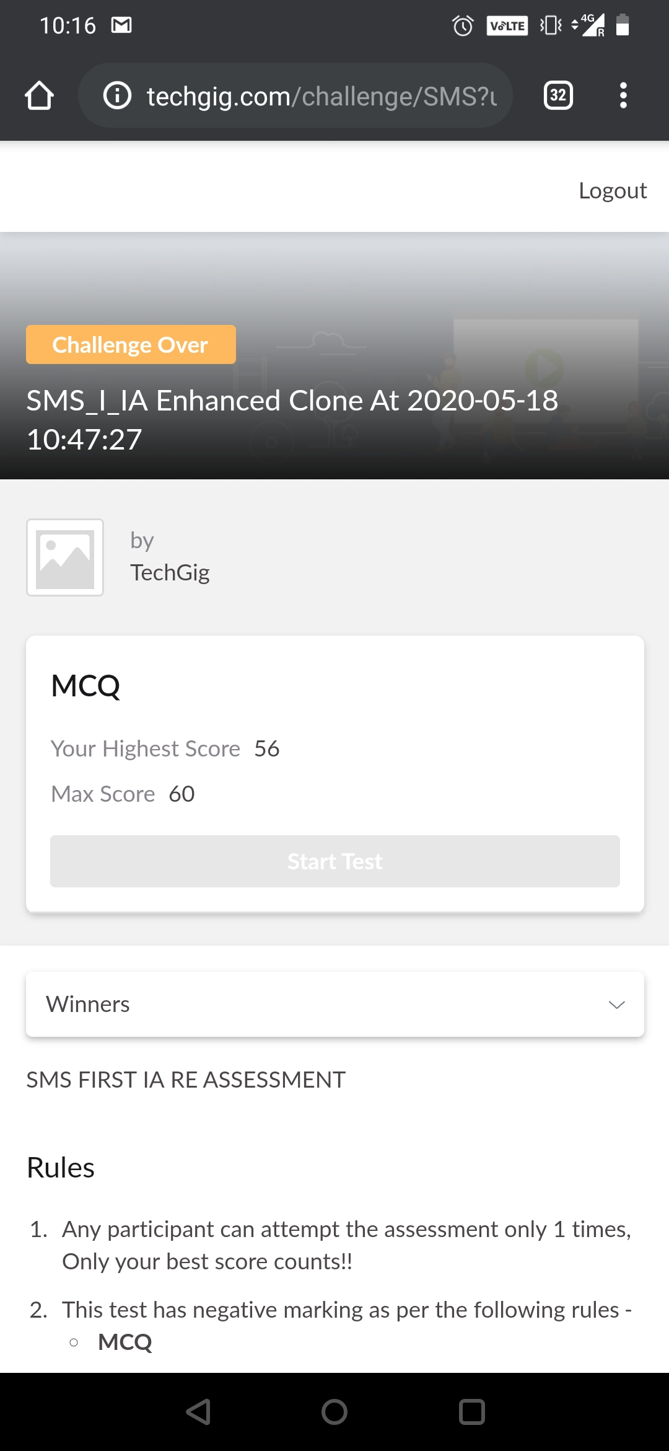

**Certification Course Details:**

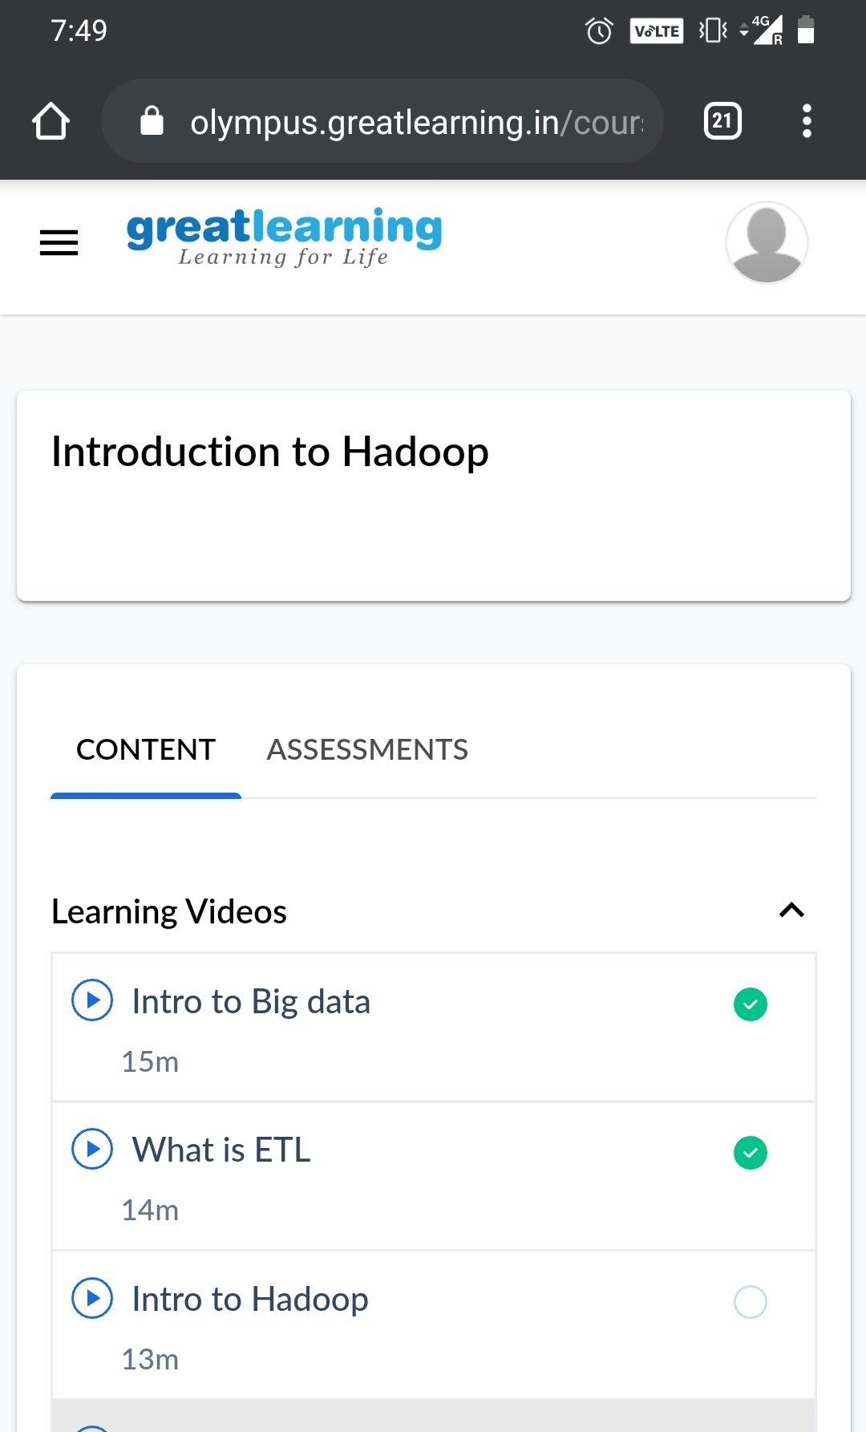

#### Introduction to BigData

Big Data is a term used to describe a collection of data that is huge in volume and yet growing exponentially with time. In short such data is so large and complex that none of the traditional data management tools are able to store it or process it efficiently.

## Types Of Big Data

## BigData' could be found in three forms:

1. **Structured**
2. **Unstructured**
3. **Semi-structured**

**Coding Challenges Details**

**Program no:1**

**package pk;**

**import java.util.Scanner;**

**public class StringOperators**

**{**

**public static void main(String args[])**

**{**

**int i;**

**String str;**

**int counter[] = new int[256];**

**Scanner in = new Scanner(System.in);**

**System.out.print("Enter a String : ");**

**str=in.nextLine();**

**for (i = 0; i < str.length(); i++) {**

**counter[(int) str.charAt(i)]++;**

**}**

**// Print Frequency of characters**

**for (i = 0; i < 256; i++) {**

**if (counter[i] != 0) {**

**System.out.println((char) i + ":-" + counter[i] + " times");**

**}**

**}**

**}**

**}**

**Program no:2**

**public class PingPong extends Thread {**

**static StringBuilder object = new StringBuilder("");**

**public static void main(String[] args) throws InterruptedException {**

**Thread t1 = new PingPong();**

**Thread t2 = new PingPong();**

**t1.setName("\nping");**

**t2.setName(" pong");**

**t1.start();**

**t2.start();**

**}**

**@override**

**public void run() {**

**working();**

**}**

**void working() {**

**while (true) {**

**synchronized (object) {**

**try {**

**System.out.print(Thread.currentThread().getName());**

**object.notify();**

**object.wait();**

**} catch (InterruptedException e) {**

**e.printStackTrace();**

**}**

**}**

**}**

**}**

**}**